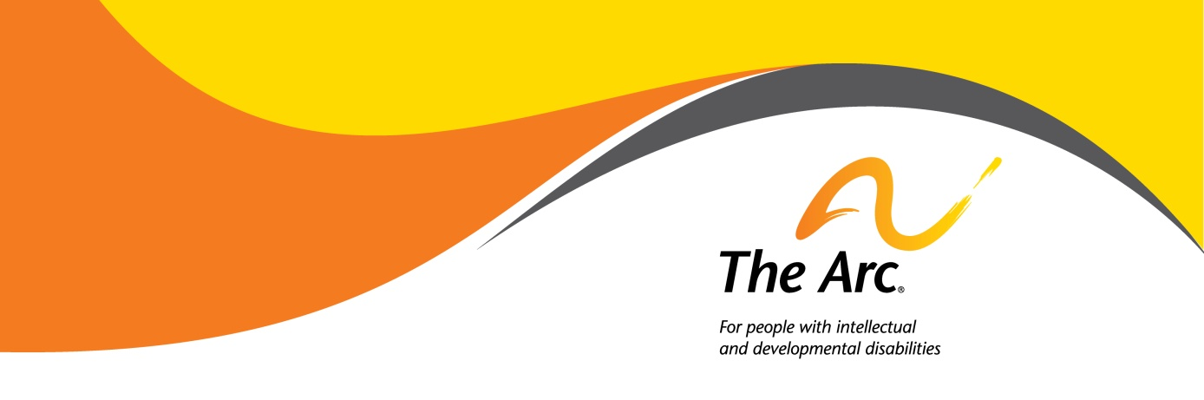
School Vouchers – Parent Decision Checklist

“School choice” is receiving much attention lately as the Trump Administration and some states are supporting a variety of school choice efforts. These initiatives come in a variety of forms - traditional vouchers, education savings accounts, tax credit scholarships, and individual tax credits or deductions. There is much confusion about these programs and whether they provide students with disabilities a meaningful choice.

This document focuses on traditional voucher (or scholarship) programs, which allow eligible students the option of using public funds for private school tuition or other educational expenses. There are currently twenty five states with such programs. States create legislation to authorize voucher programs in their state. The state legislature sets the eligibility criteria, such as the family income level, the child’s public school district’s performance, or disability status. Legislatures also establish the requirements for schools accepting vouchers, including teacher qualifications, standardized testing, data reporting, and the special education and other rights the student retains.

The Arc has not taken a position for or against vouchers, but rather is focused on ensuring that voucher programs do not adversely affect public education and, for students with disabilities, a free and appropriate public education in the least restrictive environment, access to the general education curriculum, inclusive settings, and protection of civil rights. Many voucher programs come with some features or requirements that individuals and families should be aware of because of their possible impact on educational rights. Families should carefully check the program criteria and descriptions. This document offers the following questions for families of students with intellectual and developmental disabilities (I/DD) to consider before deciding whether to support or take advantage of a voucher program:
- Are you prepared to give up some or all of your IDEA rights?
- Do you have schools to choose from in a reasonable proximity to your home?
- Can you afford to pay the difference between the voucher amount and the full cost of tuition?
- Does your child not need, or can you independently afford, special education and related services typically provided by your public school?
- Can your child meet the admissions requirements for the private school(s)?
- Are you comfortable with the school’s accountability requirements?
- Will your child’s disability increase his/her chances of being disciplined or expelled?
- Are your only options segregated settings?

- Are you prepared to give up some or all of your IDEA rights?

Under the Individuals with Disabilities Education Act (IDEA), public schools are required to provide for free appropriate public education, appropriate evaluation, individualized education plans (IEPs), least restrictive environment, parent participation, and procedural safeguards (known as “due process” to challenge school decisions). However, most states funding voucher programs do not allow students with disabilities to retain their full IDEA rights. For example, while some states have mandated that an IEP be created, families do not have a right to a due process hearing if the plan is not followed. In fact, several voucher programs require that parents waive all of their child’s IDEA rights to take advantage of a voucher.

- Do you have schools to choose from in a reasonable proximity to your home?

In densely populated areas, like cities or suburbs, there are several schools near one’s home from which to choose. However, about one-third of all schools in the United States are rural, and in these areas, it may take several hours to get to the nearest private school.

- Can you afford to pay the difference between the voucher amount and the full cost of tuition?

Most vouchers do not cover the full cost of tuition at private schools. Parents can be left to pay anywhere from $2,500 to $14,000 per year out-of-pocket for their child’s tuition. Private schools may charge additional fees, for things such as registration, books, technology, and planning for or documenting progress for students with disabilities. It is important to get a full cost of attendance from each school to understand the whole cost. Some schools offer merit or need-based scholarships, so it is worth investigating these options and their criteria for selection.

- Does your child not need, or can you independently afford, special education and related services typically provided by your public school?

Public schools are required by law to provide students with related services that allow the students to access their education. This includes things like occupational therapy, speech therapy, and physical therapy, as well as transportation to and from school. Private schools receiving vouchers do not have to offer the same services. Most voucher programs do not include costs for transportation, so parents must independently arrange and pay for their child’s transportation to school. Some private schools may offer various therapies, but they are not required to do so. Parents should inquire about which, if any, services are offered at the private schools, and determine whether their family can afford to pay for these services on their own.

- Can your child meet the admissions requirements for the private school(s)?
Public schools are required by law to educate students with disabilities. Most private schools accepting vouchers are not required to admit all students; they can choose not to take students for a number of reasons. First, parents should ask which private schools in their area accept students like their child.

If the schools are open to students with disabilities, then parents should weigh whether their child would in fact be admitted to those schools. Private schools often evaluate a child’s academic achievements and disciplinary history when considering them for admission. In addition, many voucher programs are used for religious schools. These schools may give an admissions preference to students of that same religion, which is something to consider if the child is of a different or no faith.

- Are you comfortable with the school’s accountability requirements?

Private schools do not have the same accountability and public reporting requirements as public schools. Many states do not require that private schools submit to state testing, and there is little to no supervision or monitoring of the quality of education that children with vouchers receive. It may be difficult for parents to assess the efficacy of the private schools using data; parents must determine if they have other indications that the private schools are in fact providing a quality education.

In general, there is very limited data on what happens to students after they enroll in private school. Because of this lack of transparency, it is possible that the school has accepted students with I/DD in the past, and quickly asked them to leave. Parents might want to consult with other parents at each school or a local chapter of The Arc before enrolling their child there to get a broader context of the school’s track record with students with disabilities.

- Will your child’s disability increase his/her chances of being disciplined or expelled?

In public schools, students with disabilities have some additional protections when they are disciplined. If a school wants to suspend or expel a child with an IEP for more than 10 school days, the school must convene a meeting to make a “manifestation determination.” If the child’s disability caused the behavior in question, then the school cannot discipline the child for that behavior. If the child’s behavior was unrelated to his/her disability, then the school’s policies and their state’s laws and regulations may allow them to discipline the child, which could include restraint, seclusion, suspension and expulsion.

In general, voucher programs do not restrict private schools’ disciplinary policies or practices. This may make students with disabilities who have challenging behaviors more susceptible to being suspended or expelled by private schools. Parents should review private schools’ discipline policies, and inquire as to any accommodations that may be made for students with disabilities.

- Are your only options segregated settings?

Students with disabilities may not have many options for inclusive, private education. The only schools accepting them may be schools especially designed for students with disabilities. Parents of public school students with disabilities should consider whether the benefits of the disability-specific programming at private schools outweighs the opportunities for inclusion that exist at the public school.

Selene Almazan & Denise Stile Marshall, Council of Parent Attorneys & Advocates, School Vouchers and Students with Disabilities: Examining Impact in the Name of Choice, (June, 2016) [Hereinafter “COPAA Report”].
Id.
Id.
Id.
Johnson, J., et. al, Why Rural Matters 2013-2014: The Condition of Rural Education in the 50 States, Rural School and Community Trust, (May 2014).
United States Government Accountability Office, School Choice: Private School Choice Programs Are Growing and Can Complicate Providing Certain Federally Funded Services to Eligible Students, (August 2016).
Council of Parent Attorneys and Advocates, supra note 1.
United States Government Accountability Office, supra note 7.
Council of Parent Attorneys and Advocates, supra note 1.
United States Government Accountability Office, supra note 7.
Id.
United States Government Accountability Office, supra note 7.
Id.
Id.

